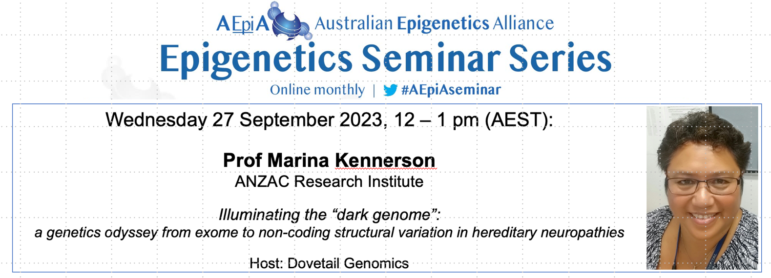

Prof Kennerson is a Professor of Neurogenetics/Neurosciences with the ANZAC Research Institute, Sydney Local Health District (SLHD) and the School of Medical Sciences, University of Sydney, Australia. She heads the Translational Gene Discovery and Functional Genomics Inherited Peripheral Neuropathies Program at the ANZAC Research Institute. Her team has discovered several neuropathy genes and is doing pioneering research to investigate the role of structural variation and its role in new disease mechanisms for hereditary neuropathies. Her research program includes functional studies for recent gene (ATP7A and PDK3) and SV mutation (CMTX3 and DHMN1) discoveries using induced pluripotent stem cell derived motor neurons and animal models (C. elegans). Marina is a board member of the Charcot-Marie-Tooth and Related Neuropathies Consortium (CMTR), Chair of the Asian Oceanic Inherited Neuropathy Consortium (AOINC) serves on the Scientific Advisory Board of the CMT Research Foundation, USA and is Deputy Director (Research) of the SLHD Institute of Precision Medicine and Bioinformatics.

Registration Link:
https://www.eventbrite.com/e/aepia-epigenetics-seminar-series-tickets-563809648837

