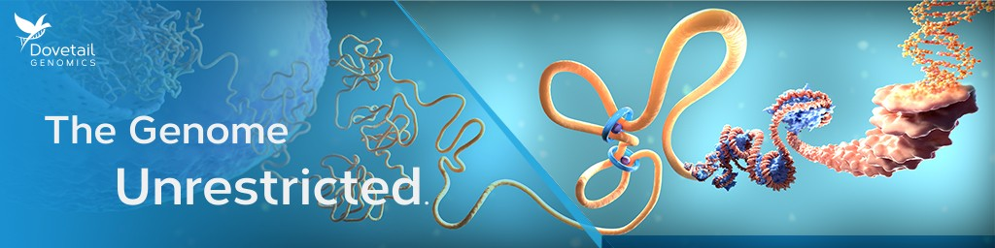

Webinar: 3D Genomics Experimental Considerations

Date
Aug 10, 2023 3PM (Auckland)

Join us for an insightful talk on 3D Genomics, where we will walk you through what is involved in designing and running a 3D Genomics experiment in the lab, sharing tips and best practices. We will also highlight how to QC the library, and what resources are available to navigate data processing. There will also be an opportunity to ask questions to our expert scientist.

What you'll learn:
- How to design a 3D Genomics experiment.
- What is involved in running a 3D Genomics experiment in the lab.
- How to navigate data processing and QC analysis.

Registration Link
Speaker

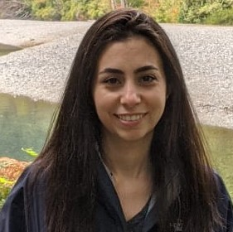
Myriam El Khawand, Ph.D.
Senior Customer Success Scientist
Dovetail Genomics, part of Cantata Bio

