



**CurationDIS - Drilling Information Systems**



# CurationDIS-OAR – Comments and Questions

Required Software:

I think the University of Otago has already a license to operate a Microsoft SQL-Server 2008R2 (Standard Edition) and Microsoft Access 2010 (32-bit) is also available because you have already worked with an ICDP-DIS. Is this correct?

*Yes, this is correct. I understand that you will be developing a DIS that is compatible with all versions of SQL Server (2012-2018), but that we will need to maintain our Access 2010 subscription – this may be problematic because Microsoft will not support Access 2010 soon. I have requested that our ITS department tell me what our policy will be on continuing to subscribe to unsupported software and will respond to you when they do to me.*

*However, the advice I have so far is that in Oct 2020 when Microsoft stops supporting Access 2010, the University of Otago will not want computers running it on their network. This will be a problem for us. Is there any alternative to using Access 2010?*

There will be appropriate hardware with a server operating system (Windows Server 2008 or Server 2012) to operate the system for the repository.

*I intend to install the ‘in office’ version of the database on one of the computers that we used for the DIS during the Alpine Fault Drilling Project (DFDP), and have a second version on a laptop (also used during DFDP) that can be taken out of the office to new drillsites. Ronald Conze seems to think that this will be appropriate for now. If it becomes clear in future that we need a higher spec computer I will obtain one. The current computer is running Windows 7 Pro. The only server software on it is SQL Server.*

*However, the University of Otago has license agreements with Microsoft for all Microsoft products so if something like Windows Server 20XX is needed we will buy a license for it and install it on this computer. Is that OK?*

For printing labels with QR-codes a label printer like Zebra GX 430T or a compatible model is available.

*Yes, we have two of these exact printers.*

Is this correct?

The title / name for the system will be CurationDIS-OAR. Other suggestions are welcome.

*This sounds good to me.*

I need two images for the start window of the system. I have sent some example images (DIS_left.jpg and DIS_bottom.jpg). Please prepare two images of the same size with your favorite motives.

*We would be happy to use your images if we are allowed to. If not, we will make some.*

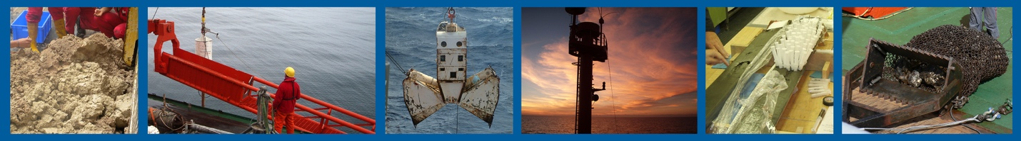

I need an icon/logo for the system. Should I use the logo of the University or is there already a logo for the OAR. Suggestions are welcome.

*We need to make an OAR logo. I will suggest this to our group tomorrow. VT will ask media and communications office in Div Sci.*

The initial system for OAR will support the following coring devices:

Drill Rig (RIG)

Gravity Corer (GC)

Grab Sampler (GS)

Mini Corer (MIC)

Multi Corer (MUC)

Piston Corer (PC)

Vibro Corer (VC)

Rock Drill (RD)

*Box Corer (BC)*

*Mackareth Corer (MC)*

*Livingston Piston Corer (LPC) – yes this does need to be distinct from PC*

*Other (OC)*

The system will support water bottles/samples from the following devices:

Mini Corer (MIC)

Multi Corer (MUC)

Rock Drill (RD)

*Drill Rig (RIG)*

Conductivity, Temperature, Depth + water sample rosette (CTD+RO)

The system will add support for core boxes and cuttings.

Core boxes are integrated like in ICDP entered on the section page. Please check example-image below.

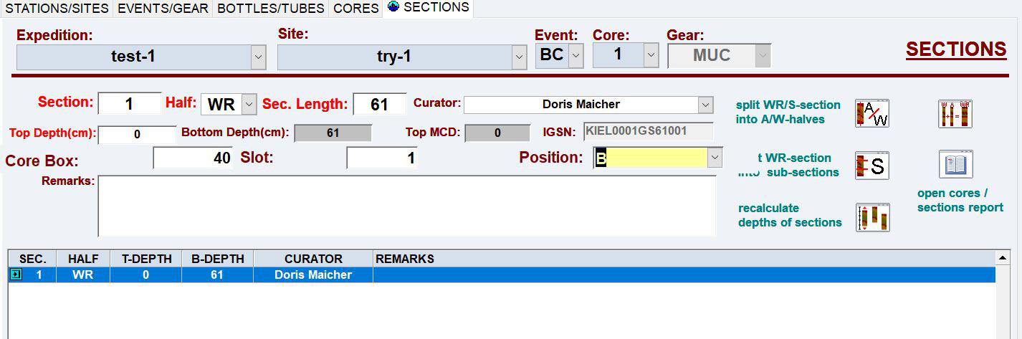

The entries for a core box will be only displayed for the device ‘RIG’ not for a ‘GC’ or ‘PC’,…

The cores from ‘GC’, ‘PC;,… wil be stored in liners/tubes.

Is this correct?

*No, even the soft cores in liners/tubes might also be put into boxes, but they might not.*

Cuttings should be managed like in DFDP-2 ?

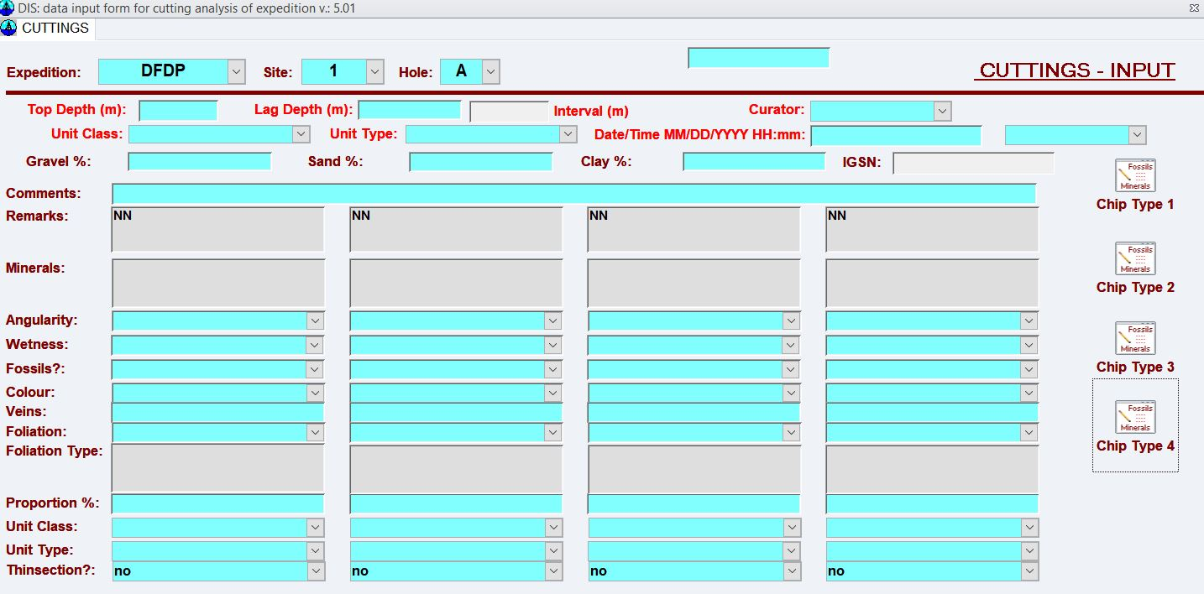

Another more common way would be this one.

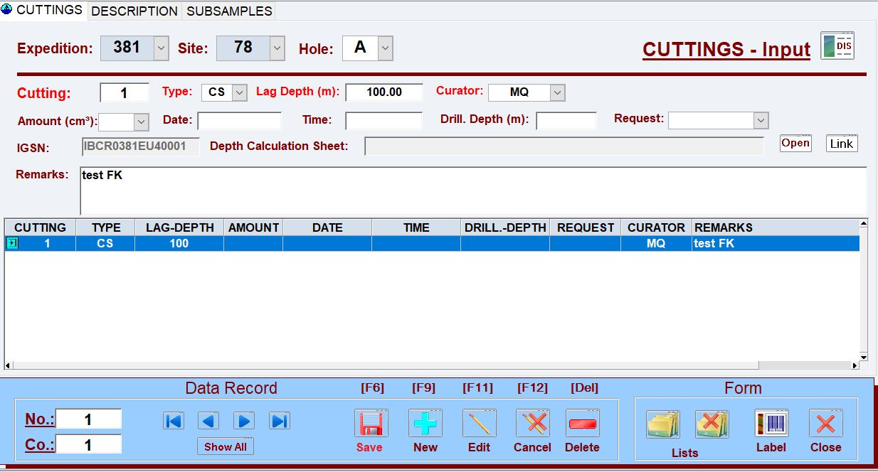

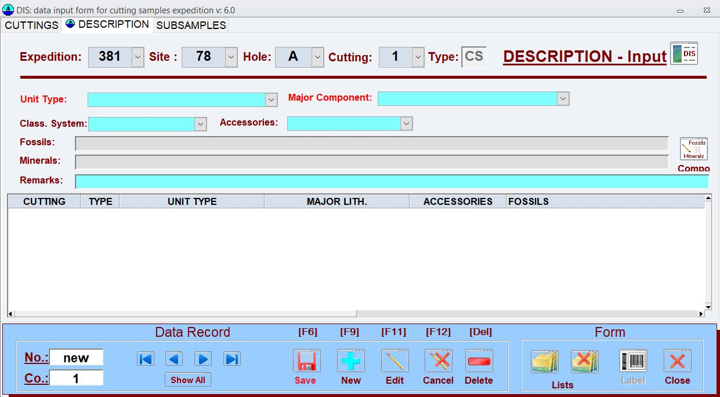

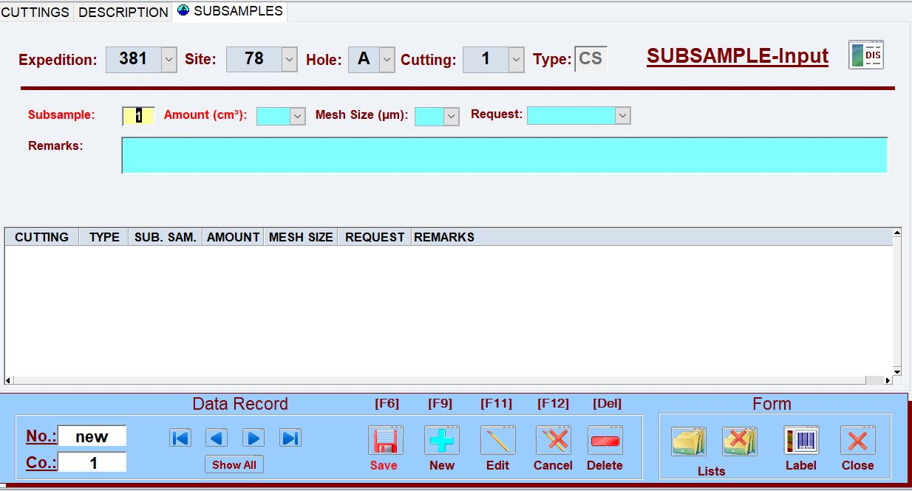

Please let me know which initial version for cuttings you prefer.

*I am happy to have this second simpler version of a cuttings input form. The DFDP one is too specific for our general projects.*

The system will add support for the section unit description.

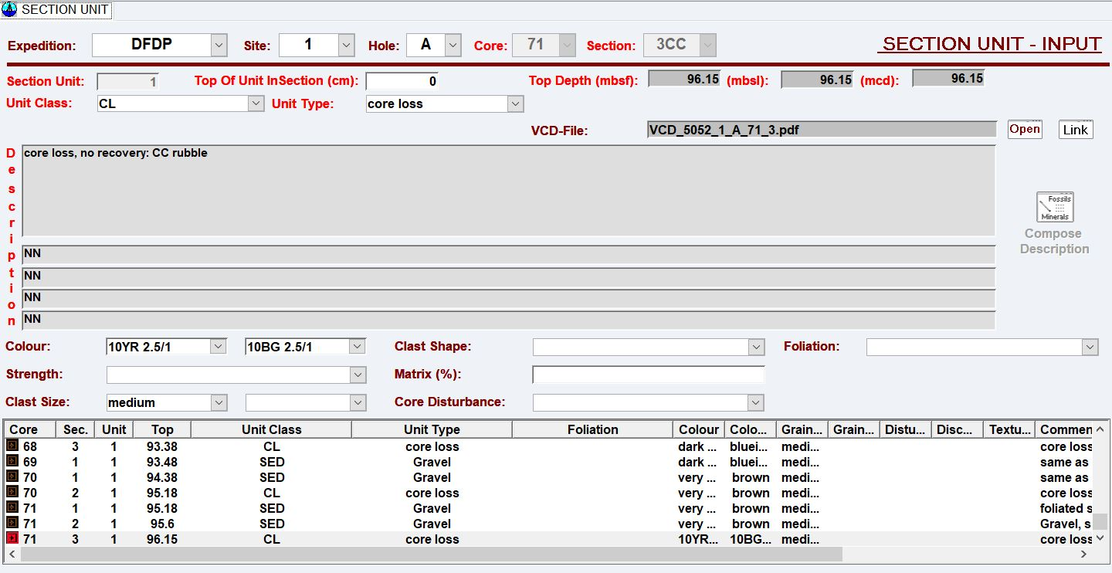Exactly like in DFDP-2?

*We will need to be able to describe sedimentary, metamorphic, and volcanic/plutonic rocks. I am not sure that we should have the same input fields as DFDP-2. For example, foliation will not be useful for the sedimentary and volcanic/plutonic rocks. Instead I suggest three different input fields depending on the chosen Unit Class, as follows:*

*Unit Class SED 🡪 Unit Type, Colour 1, Colour 2, Grain Size, Angularity, Grain types (multiple fields?), Bedding, Sedimentary Structures, Hardness, Compaction, Fissility, Cement, Weathering, Fossils*

*Unit Class IGN 🡪 Unit Type, Colour 1, Colour 2, Grain Size, Minerals (may need to be multiple fields?), What else?*

*Unit Class MET 🡪 Unit Type, Colour 1, Colour 2, Grain Size, Minerals (may need to be multiple fields?), Foliation, Lineation, Folds (Yes/no), Fault rocks?*

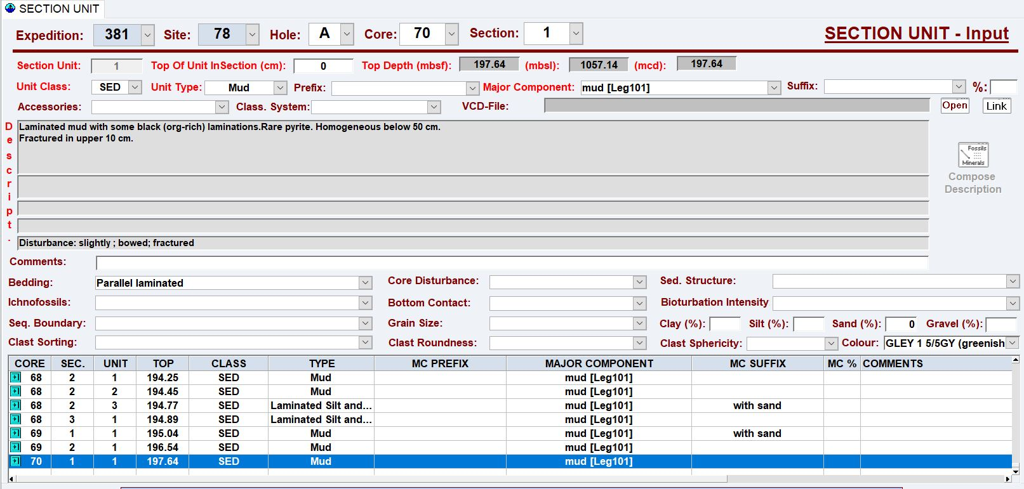

Another example for the section unit description with additional fields

Please let me know which initial version you prefer.

Regarding the naming convention for expeditions, sites, events(holes):

The system will support string identifiers for expedition, site and event (hole) up to twenty characters.

For the events/holes entries the system will only display a smaller field for up to three characters like

‘A’, ‘1’, ‘A1’, ‘AA’, AB1’



Do you need larger fields for the entry of an event/hole?

The caption of the entry ‘gear’ will be changed to ‘device’.

Cores and sections will be identified by a number.

I need a prefix ( 4 characters) for generating the IGSN’s for OAR.

Should I use ‘IOAR’? Other suggestions welcome.

*I is easily mistake for 1. Can we use UOAR?*

Thank you very much for your answers and comments.

Frank