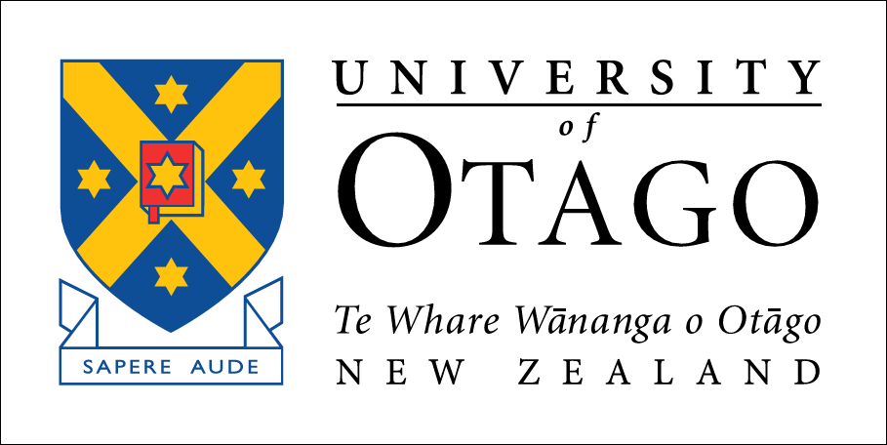

Indigenous Textual Cultures
Centre for Research on Colonial Culture

PROGRAMME

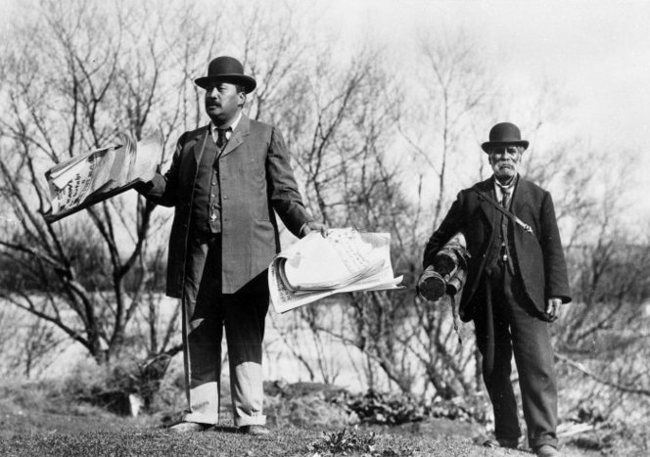
Henare Kaihau MHR, c. 1907. Ref: 1/2-071414-F. Alexander Turnbull Library, Wellington, New Zealand.

Seminar Room
Hocken Collections
Dunedin.
30 June and 1 July, 2014.

Welcome from the Centre for Research on Colonial Culture

The Centre for Research on Colonial Culture would like to welcome the participants of the symposium on Indigenous Textual Cultures. The Centre was established at the University of Otago in July 2012, its creation recognizing the existence of a particularly productive network of researchers of international standing who have fashioned a strong tradition of collaborative work.
The Centre's primary objectives are: to enable the production of new historical understandings of colonialism, the development of colonial cultures, and the role of empires in shaping the modern world; to promote discussions of the relationships between colonial histories and indigenous histories and to generate new insights into connections between New Zealand history and the broader history of the British empire and the Pacific region; and to facilitate and enrich public discussion about colonialism and its legacies, both in New Zealand and more broadly.
It is therefore fitting that the Centre is able to support this symposium in which international scholars can investigate Indigenous peoples’ interactions with textual culture across a range of colonial milieus.

Thanks

The Centre for Research on Colonial Culture would like to thank the Hocken Collections for their support in the hosting of this symposium.

Please check out the display cabinet in the foyer featuring a number of niupepa (Māori-language newspapers), curated by Jeanette Wikaira and Jacinta Beckwith of the Hocken Collections.

Day 1 – 30 June
9.15-9.30 | Mihi whakatau  Mark Brunton  Kāi Tahu, Research Manager Māori
9.30-10.30 | Isabel Hofmeyr  University of Witwatersrand  The Intellectual Property/ies of Indigenous texts: Copyright and the Imperial Commons
10.30-10.50 | Morning Tea
10.50-11.20 | Noelani Arista (Discussion*)  University of Hawai‘i at Mānoa  Ka Waihona Palapala Manaleo: Research in a time of plenty: colonialism and ignoring the Hawaiian Language Archives.
11.20-12.20 | Ārini Loader  Victoria University of Wellington  ‘Kei wareware’: a genealogy of Maori intellectual continuance and survival
12.20-1.20 | Lunch
1.20-2.20 | Laura Rademaker  Australia National University  What Literacy meant: Aboriginal challenges to writing on Groote Eylandt, North Australia.
2.20-3.20 | Emma Hunter  University of Cambridge  Swahili-language periodicals and the textual cultures of Colonial East Africa, 1923-1939.
3.20-3.40 | Afternoon Tea
3.40-4.40 | Keith Thor Carlson  University of Saskatchewan  Textuality and Memory: Cultural anxieties and the Salish relationship with literacy through History.
Drinks – Taste Merchants
Dinner – Little India 6.30pm

* Noelani Arista cannot attend in person due to family reasons but her paper will be pre-circulated for discussion

Day 2 – 1 July
9.00-10.00 | Anna Johnston  University of Tasmania  Missionary linguistics and Indigenous literacies
10.00-10.20 | Morning Tea
10.20-11.20 | Bruno Saura  Université de la Polynésie Française  Polynesian Manuscripts from the Tahitian Area: Interior history, formal logic and social uses.
11.20-12.20 | Michael P.J. Reilly  University of Otago  The textual world of Mangaia.
12.20-1.20 | Lunch
1.20-2.20 | Lachy Paterson  University of Otago  Māori literacy practices.
2.20-2.40 | Afternoon Tea
2.40-4.00 | Tony Ballantyne  University of Otago  Commentary  Followed by general discussion, including the advancing of this project.
Free time
Dinner – Thai Hanoi 6.30pm

ABSTRACTS

Noelani Arista
University of Hawai‘i at Mānoa
Ka Waihona Palapala Manaleo: Research in a time of plenty: colonialism and ignoring the Hawaiian Language Archives.

This paper begins by posing a question, how is it possible that the largest indigenous language archive in the United States and perhaps the Pacific, has been ignored by scholars? It seeks to engage with the focus questions how did indigenous textual cultures emerge and interact with older knowledge systems while also problematizing the now nearly normative assumptions that inspire scholars’ search for “agency.” I argue that although the search for agency does important work in decolonization, in other contexts, agency is also an affect of the archives’ minimalism. My question seeks to get closer to the heart of our assumptions about what it means to write “native history,” and works to reconstitute a research agenda that is more in line with the actual sources before us.
This work focuses a critical lens upon the impoverished and attenuated discourses that were allowed to flourish out of colonial zones of contact, which after the turn of the twentieth century (in Hawai’i) privileged knowledge of “the native,” through English-language-only source materials. The privileging of the “native voice” on the part of Euro-American and indigenous scholars must be framed alongside historiographic formations that left “native voices” speaking in native languages on the other side of an evidentiary divide, a practice so legitimated as to allow for the ignoring of the archive in plain sight. In doing so, this work reaches for select examples to illuminate “indigenous engagement with text during the colonial period,” and is interested in pointing out the continuity of aural/oral pedagogical discipline in the crafting of and dissemination of knowledge. Hawaiian knowledge systems were strictly disciplined through the training of aural/oral intellects all throughout the period of contact, encounter and settlement. I suggest that scholars look to these disciplinary standards as applicable modes of accountability---to frame our practice. An accountability founded on the same ideal of rigor, albeit ones which are indigenous to the texts and contexts out of which they were produced.

Keith Thor Carlson
University of Saskatchewan
Textuality and Memory: Cultural anxieties and the Salish relationship with literacy through History.

As an ethnohistorian working with and among the Coast Salish people of the northeast Pacific Rim I am less interested in the history of Aboriginal people in western/colonial society than I am with the story of modernity and colonialism within Aboriginal histories. And what intrigues me most is not the weighing of cultural continuity against colonial-induced change, but in assessing the process of change within structures of continuity and the forces of continuity within systems of change; the deployment of innovation both within and against tradition, and vice versa. It appears clear that insights into these issues can be gleaned through an examination of the dynamic non-dichotomous relationship between events and structure as played out in the theatre of colonial encounters. Toward this end, in this paper, I present and analyze what might be considered three ethnohistorical vignettes, each relating to an aspect of the historical relationship between orality/memory and textuality/literacy in Salish history. The first pertains to Salish oral traditions describing an ancient alienated literacy that in turn explains colonialism. The second examines colonial-era Native engagements with literacy as a communication technology within the context of spirit quests. And the third studies a current anxiety within Salish society over documented changes in legendary origin stories as revealed through anthropologists¹ field notes recorded over the past 130 years in relation to an oft spoken protocol that supposedly requires story tellers not to change or modify myth-age stories. Through these vignettes I seek to better understand the tensions within Salish society between event and structure; between people who oppose change and those who embrace it, the strategies they deploy, the motivations behind their actions, and the implications of their acts in the broader context of Native-newcomer relations.

Isabel Hofmeyr
University of Witwatersrand
The Intellectual Property/ies of Indigenous texts: Copyright and the Imperial Commons

In terms of its rubric, this conference aims to explore “indigenous engagement with text during the colonial period”. Arguing that ideas of indigeneity need to be placed against an imperial framework, my paper explores forms of indigenous textuality that enter the transnational weave of newspapers, periodicals and pamphlets that circulated across the colonial world.
Whereas much scholarship on indigenous textualities relies on models of “possessive collectivism” (territorialized ethnicity, nation and /or ethnic nation), this paper argues for a “dispossessive collectivism” (to draw on Emily Apter’s term) which casts texts “as an unownable estate, a literature over which no one exerts proprietary prerogative and which lends itself to a critical turn that puts the problem of property possession front and center” (Apter, Against World Literature, 329). Drawing on a term that Antoinette Burton and I explore in a forthcoming collection (Ten Books that Shaped the British Empire: Creating an Imperial Commons), this paper investigates how one might think of indigenous textualities as part of an imperial commons. As a sub-theme in this investigation, the paper explores contending ideas of literary and intellectual ownership and how these shape the institution (or non-institution) of colonial copyright legislation.

Emma Hunter
University of Cambridge
Swahili-language periodicals and the textual cultures of Colonial East Africa, 1923-1939.

This paper explores Swahili-language newspapers and periodicals in Tanganyika in the period from 1923 to 1939. This body of printed sources has long suffered relative neglect, largely because, in contrast to the lively independent African press published in Kenya and Uganda, most Swahili-language newspapers and periodicals published in Tanganyika were produced by missions and the colonial government and were generally not nationalist or anti-colonial in content. Yet while they were edited and financed by Europeans, they were published in African languages for African consumption and with much of the text provided by African writers, including, for example, translations of European texts, poems and letters and questions addressed to the editor. Crucially, these periodicals had an over-arching editorial line with which contributors were compelled to engage in order for their contributions to be published. They therefore became a key site for both the promulgation and development of new discourses and formed the basis of what might cautiously be termed a colonial public sphere.
This paper begins by setting Swahili-language newspapers and periodicals in the context of the reading and writing cultures of interwar East Africa and the specific political context of interwar Tanganyika. It then moves on to explore the discourses constructed through Swahili language newspapers and periodicals, focusing specifically on the government periodical Mambo Leo and the Lutheran church periodical, Ufalme wa Mungu. While the paper focuses on Tanganyika, it situates Tanganyika in a wider context and draws out comparisons with discourses developed in similar print forms in other parts of the colonial world.

Anna Johnston
University of Tasmania
Missionary linguistics and Indigenous literacies

Beginning with language collection—often first undertaken by missionaries keen to proselytise in local languages—Europeans from first contact onwards sought information from indigenous informants, often in close quarters in campsites, isolated huts, and on board ships. Missionaries were often the key cultural intermediaries in collecting languages, even as their work displaced local languages and customs. Later, curious settlers, magistrates, and officials often collected language and ethnographic data alongside their other roles in colonial polities. At times well-intentioned, at times frankly exploitative, these relationships in search of knowledge represent the entangled intimacies of colonial cultures.
Touching body parts and seeking to exchange names, learning language brought indigenous and European peoples into close contact. These moments also offered insight into the complex relations inherent in colonial encounter. Aborigines at Lake Macquarie laughed at Rev Lancelot Threlkeld’s poor Awabakal accent and slow grasp of linguistic concepts, for example. Linguistic collection recast relationships between missionaries and their Indigenous constituents in sometimes unexpected ways. Yet, as Joseph Errington notes, linguistic projects served collateral purposes in colonial expansion (and beyond that, the British Empire), such that language difference became a means for marking and reinforcing inequality in colonial culture.
Knowledge of Indigenous language and culture undoubtedly provided tools for European settlers to displace those cultures, however it also enabled greater understanding of the experience of Indigenous people under colonisation, and spurred some settlers to advocate for indigenous interests because considerable information about colonial violence emerged through these processes. This paper focuses on settler and Indigenous involvement in linguistic and ethnographic data collection by analysing particular language collectors in colonial Australia and tracing their connections to imperial networks of linguistic study, settler colonial debates about Indigenous culture and rights (the latter often played out in law courts), as well as considering contemporary Indigenous responses to ethnographic surveying. Linguistic and ethnographic data provides a rich resource for understanding the nexus between intimacy and violence, the relationships between settlers and Indigenous peoples, and the textual culture forged through this site of exchange.

Arini Loader
Victoria University of Wellington
‘Kei wareware’: a genealogy of Maori intellectual continuance and survival

In the mid 1850s Tamihana Te Rauparaha wrote a manuscript about the life of his father, the (in)famous Ngati Raukawa/Ngati Toa rangatira, Te Rauparaha. After introducing his subject, Tamihana gives his authorial signature and reason for writing the manuscript, ‘Na Tamihana Te Rauparaha i tuhituhi kei wareware’. Discourses of erasure have underlied the terms of engagement between Indigenous peoples and colonisers since the early contact period and persist to the present day. Contrastingly, this paper explores Tamihana Te Rauparaha’s assertion that he wrote the manuscript ‘Lest it be forgotten’ as a broader expression of Maori continuance and survival. Ultimately, this paper argues that nineteenth-century Maori critically reflected upon their rapidly changing world and recorded their doubts and fears for the future both through and by the medium of the written word.

Lachy Paterson
University of Otago
Māori literacy practices.

Colonial power in New Zealand was predicated on literacy, text and print, in English and in Māori. The evidence of nineteenth-century Māori literacy, and when it occurred, is patchy, but in the years preceding the Treaty of Waitangi, missionaries optimistically viewed a supposed high level of literacy as proof of conversion to Christianity and civilization. Some historians also accepted this viewpoint, in part to illustrate Maori achievement and ready engagement with modernity. For example, C.J. Parr (1963) suggests that in 1850 that ‘about half the adult Maoris could read Maori and about one-third could both read and write it,’ but this resulted from a lag from earlier enthusiasm, with literacy acquisition declining after formal colonization began. In 1985 D.F. McKenzie, in his slim but influential volume, Oral Culture, Literacy & Print in Early New Zealand: The Treaty of Waitangi, discounted the likelihood of meaningful Māori engagement with text before 1840, suggesting that Māori society was still essentially oral in nature at that time. In response Lyndsay Head and Buddy Mikaere (1988) argued that Māori literacy began and continued from the 1830s.

While the signing of names rather than crosses (a technique applied by McKenzie to the Treaty of Waitangi) may have some validity for determining literacy in modern societies in which individuals experience atomized existences, it has critical shortcomings when applied to communal tribal societies, such as Māori in nineteenth-century New Zealand. Some scholars, perhaps reflecting their own modern societies, also conflate literacy with education but many Māori, particularly in the early nineteenth century gained their ability to read informally from other Māori readers, and sustained schooling did not become widespread until some decades later. While briefly surveying the extent of literacy, this paper seeks to explore more pertinent questions around what I describe as literacy practices: how did texts and practices around literacy impact Māori life; what access did individuals, including non-literates, have to the world of writing and print so important in the colonial world; and were literacy practices a site of oppression or agency for Māori of the nineteenth century.

Laura Rademaker
Australia National University

What Literacy meant: Aboriginal challenges to writing on Groote Eylandt, North Australia.

In many places where missionaries introduced the written word, indigenous people eagerly adopted literacy. Writing in English has had strategic, practical benefits in terms of negotiation with colonisers but books and newspapers also offered new types of entertainment and enjoyment. Yet, for other peoples, literacy was not an ideal. The use of documents as mechanisms of control in the context of unequal power relationships has shaped how indigenous people perceived literacy. Writing became laden with cultural meanings not always readily reconciled with indigenous identities.
This paper looks to the experience of Anindilyakwa people of the Groote Eylandt archipelago in the Northern Territory of Australia on their encounter with evangelical missionaries of the Church Missionary Society of Australia (CMS) in the mid-twentieth century. The ability to read was fundamental for missionaries. They saw instilling English literacy as indicative of their success as civilisers and evangelists as well as a means of empowering Aboriginal people as equal citizens and disciples. Yet despite missionary encouragement, many Anindilyakwa speakers never became literate in English.
This paper sheds light on the Anindilyakwa challenge to missionary presumptions about the universal utility of English literacy and its proper purposes. For many of those who did not accept or welcome the missionaries’ agenda and who observed the symbolic meanings of literacy to the missionaries, becoming literate in English was a concession they were not willing to make. This paper argues that where Anindilyakwa people used writing, they used it in ways missionaries did not foresee, particularly in ways that simultaneously upheld oral systems of knowledge. Anindilyakwa people did not reject literacy, but used written texts in diverse, oral and more Aboriginal ways, sometimes even to subvert the ‘Christian civilisation’ offered by missionaries.

Michael P.J. Reilly
University of Otago
The textual world of Mangaia

This paper explores aspects of Mangaia’s textual world through a close study of two versions of a local oral tradition that recounts what happens when a male leader forces a subordinate woman to locate drinking water for him during a drought. The first version, originally a sermon preached by a Mangaian pastor, utilised the tradition to affirm Christian values; a written version was published in 1876. Christianity was first embraced in Mangaia in 1824: reading and writing were seen as distinctive practices of the new religion’s adherents. Ancestral knowledge began to be written down and drawn on to explain Christian ideals, as in the 1876 sermon. The sermons by Mangaian preachers utilised many performance techniques from the older oral world of the ancestors. The second version of the oral tradition is a transcription of a 1974 tape recording made as part of a Cook Islands government project to create a national cultural identity. Experts who participated stressed the importance of educating the generations at school, so that they retained their ancestors’ knowledge in the modern world.
The paper identifies various cultural and ecological themes that emerge in the two versions: the cruel and caring polarities of Polynesian leadership; the intervention of spirit powers and their human mediums in protecting those abused by leaders, and punishing those who break customary rules governing human society; and, the deeply integrated relationship that exists between a human society and their local, island environment. The written versions of the tradition reveal the ghostly presence of the oral tradition within their texts, including the use of repetition, dialogue and sayings; all elements of the ancestral oral world. These two versions stress the continuing primacy of orality in Mangaia’s textual culture. In the longer run literacy and Christianity were converted to become the means by which Mangaian society preserved many of the old ancestral traditions. These became so closely integrated with the new order that it is hard to discern where one ends and the other begins. The modern recording apparatus used to preserve the two versions serve to pass on the words of the ancestors to the young, ensuring they acquire the knowledge that helps them live and work in Mangaia. The texts become vehicles for the continual retelling and recollection of traditions by a new generation, as the stories move from written to oral forms and back again. The unceasing transmission and dissemination of the ancestral body of knowledge sustains a distinctive and unique Mangaian culture into the future.

Bruno Saura
Université de la Polynésie Française
Polynesian Manuscripts from the Tahitian Area: Interior history, formal logic and social uses.

The first native manuscripts appeared in French Polynesia in the XIXth century, following the appropriation of writing by the native people. This phenomenon concerns mainly the Protestant Austral islands and Leeward islands, where the influence of the Bible was and is still very strong. In the Austral islands like Rurutu, these ‘’neo-traditional’’ writings, called puta tupuna (books - of the - ancestors), still play an important part in the justification of land rights, through very controversial genealogies. Although often kept jealously by their owners, these texts inspire other recent native works, based on them but influenced by contemporary western writings and ethnological theories.
After a diachronic study of some Rurutu manuscripts, will be introduced two puta tupuna recently published in Tahiti, from the Leeward islands. The first one, which seems to be the most ancient Polynesian manuscript (1846), deals with traditions of Huahine and Borabora, and the reasons of the conversions from a native point of view. The second one deals with the history of the Tamatoa royal family from Raiatea (marae Vaearai and Taputapuatea). They can be considered as very valuable interior Polynesian history and perhaps ‘’literature’’. Not only do their authors try to ‘’tell’’ the past and conserve the memory of pre-european traditions, but they also constitute an attempt to soothe and rationalize history, where men and events have not always been coherent.
Lastly, these puta tupuna (those from Rurutu and those from the Leeward islands) will be reconsidered with the help of Jack Goody’s theories about literacy and the logic of writing. We will see how in these islands, although undeniable interferences between ''orality'' and ''literacy'', the apparition and development of a culture of writing has not necessarily lead to the emergence of a tradition of skepticism and a scientific culture in the Western meaning of the term.

NOTES

NOTES

