https://blogs.otago.ac.nz/agotago/events/
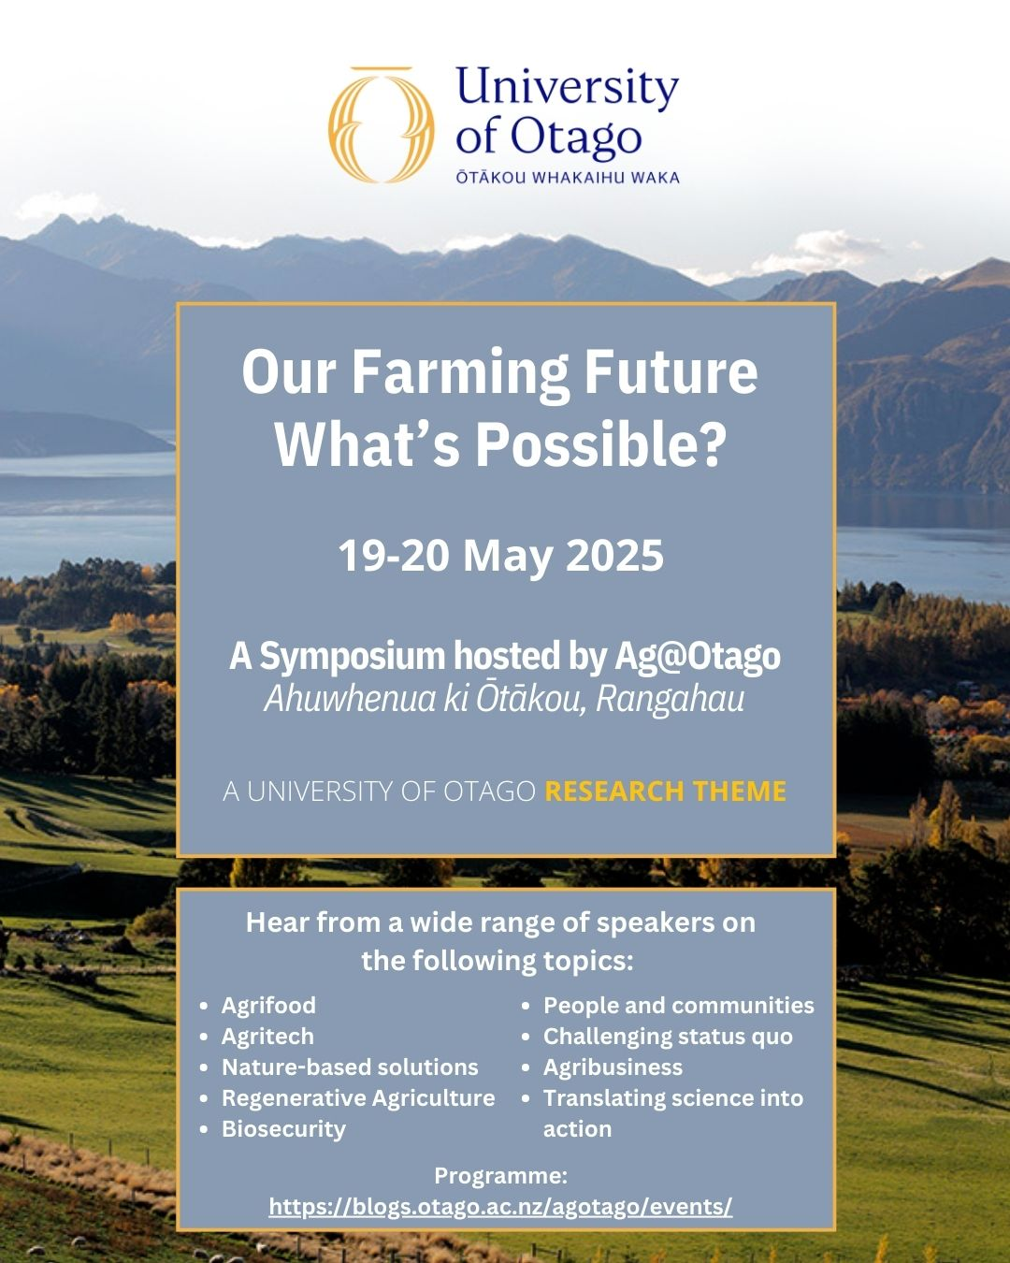

Day One: Monday 19th May
START OF DAY: 10 am
Tea and coffee available

Opening Session 1: Day One
10:30-10:50am
Prof Craig Bunt
Join us for the opening session where we will kick off the symposium with welcoming remarks, an overview of the programme, and plenary talk. This session will set the stage for the insightful discussions to follow, providing a comprehensive introduction to the themes and objectives of the event.
Hon Mark Patterson
We are honoured to welcome Hon Mark Patterson, Minister for Rural Communities and Associate Minister of Agriculture, to open this year’s Ag Symposium. A seasoned Otago sheep and beef farmer, Minister Patterson brings over 30 years of hands-on experience. He has served as Chair of Otago Federated Farmers (2021–2023) and has been a strong advocate for rural communities since entering Parliament in 2017. His commitment to primary sector and it’s communities make him a fitting guest to launch our future-focused farming symposium.

Panel Session 1: Agrifood, The Intersection of Agriculture and Food Production
11:00-11:50am
Session Chair: Prof Indra Oey
The intersection of agriculture and food production. This session will address the challenges and opportunities within the agrifood sector, exploring innovative approaches to food production, processing, and distribution that ensure sustainability and food security.
- Dr Jessica O'Connor Department of Food Science, University of Otago
- Daniel Carson Mīti
- Prof Aladdin Bekhit Department of Food Science, University of Otago
- Anna Benny
- Dr Victoria Hatton foodHQ

LUNCH: 11:50-1:00pm

Panel Session 2: Agritech I
1:00-1:45pm
Session Chair: Prof Janice Lord
Explore the cutting-edge innovations in agricultural animal and plant technology. This session will highlight advancements that enhance efficiency and sustainability in farming practices. Participants will learn about the latest tools and technologies that are transforming the agricultural landscape.
- David Macdonald AgriZero
- Ben Lee Agilis Vets Limited
- A/Prof Lynette Brownfield Department of Biochemistry, University of Otago
- Kylie Horomia AgriTechNZ

Panel Session 3: Agritech II
2:00-2:45pm
Session Chair: Prof Craig Bunt
Explore the cutting-edge innovations in agricultural information and computer science technology. This session will highlight advancements that enhance efficiency and sustainability in farming practices. Participants will learn about the latest tools and technologies that are transforming the agricultural landscape.
- Warren Bebb Sprout Agritech
- Brendan O'Connell AgriTech New Zealand
- Prof Peter Mace Department of Biochemistry, University of Otago
- A/Prof Greg Walker School of Pharmacy, University of Otago

BREAK: 2:45-3:15pm

Panel Session 4: Nature Based Solutions
3:15-4:00pm
Session Chair: Dr Annie O'Connell
Explore how adopting nature-based systems in agriculture can promote sustainability, resilience, and ecological harmony. This session will delve into innovative nature-based solutions, featuring inspiring case studies and practical applications that enhance environmental health while boosting agricultural productivity.
- Professor Janice Lord Department of Botany, University of Otago
- Toula Finlayson Southland Carbon
- Nathan Anderson Otago Regional Council
- Dr Nathan Kenny Department of Biochemistry, University of Otago

Pannel Session 5: Regenerative Agriculture
4:15-5:00pm
Session Chair: Dr Annie O'Connell
Dive into the principles and practices of regenerative agriculture, exploring how they restore soil health, enhance biodiversity, and build resilience in agricultural systems. This session will highlight real-world examples and practical strategies that demonstrate how regenerative approaches can benefit both the environment and agricultural productivity.
- Mark Anderson Westridge Dairy Farm
- Conan Moynihan Force of Nature Consulting
- Chanelle O'Sullivan Harvested Media
- Amy Maw The Whole Story

Panel Session 6: Biosecurity
5:15-6:00pm
Session Chair: Prof Craig Bunt
This session will delve into the latest developments and challenges in biosecurity, focusing on strategies to protect our agriculture from pests and diseases. Attendees will gain insights into innovative approaches and collaborative efforts aimed at safeguarding our biosecurity.
- Dr Helen Beattie Veterinarian for Animal Welfare Aotearoa
- Dr Tom Brownlie Ingenum
- Aaron Hewson Future Farmers
- Kim Kelly MSD Animal Health

END OF DAY: 6:00 pm

Day Two: Tuesday 20th May
START OF DAY: 9.00 am
Tea and coffee available

Opening Session 1: Day Two
9:15-9:30am
Prof Craig Bunt
Continue the symposium with additional opening remarks and an outline of the day's agenda. This session will prepare attendees for another day of engaging discussions, providing a brief recap of the previous day's highlights and setting the tone for the sessions ahead.

Panel Session 7: People and Communities
9:30-10:15am
Session Chair: Lucy Brown
Examine the crucial role of communities in supporting agricultural practices and the well-being of rural populations. This session will highlight community-driven initiatives and their impact, emphasizing the importance of social cohesion and support networks in fostering sustainable agricultural development.
- Richard Kyte Thriving Southland
- Kathryn Wright Centre for Sustainability, University of Otago
- Melanie White Otago Regional Council
- Kim Reilly Ministry for Primary Industries

BREAK: 10:30-11:00am

Panel Session 8: Beyond the status quo
11:00-11:45am
Session Chair: Prof Craig Bunt
Explore innovative ideas and diverse voices shaping the future of agriculture in Aotearoa. From fostering inclusivity and leadership to empowering rangatahi and young farmers, the speakers will highlight initiatives driving a sustainable and vibrant sector.
- Lucy Brown
- Madeleine Ford Department of Biochemistry, University of Otago
- Dr Jordi Hoult

LUNCH: 11:45-12:45pm

Panel Sessions 9: Agribusiness I
12:45-1:30pm
Session Chair: Dr Damien Mather
This session will explore key topics and emerging trends in sustainable finance, investment, and reporting, featuring insights from potential expert speakers.
- Manu Caddie
- Julia Gorinski Westpac
- Dr Sebastian Gehricke Department of Accountancy & Finance, University of Otago

Panel Session 10: Agribusiness II
1:45-2:30
Session Chair: Dr Sebastian Gehricke
This session will highlight innovative approaches to agribusiness management, showcasing innovators and emerging leaders who are steering the way in diversification and sustainability. Key speakers include:
- Becks Smith Solayer
- Dr Damien Mather Department of Marketing, University of Otago
- Annie Cates Farm Focus
- Claire Booker Silver Fern Farms

BREAK: 2:30-3:00pm

Panel Session 11: Translating science into practice, and close
3:00-3:45pm
Session Chair: Neal Wallace
Learn how scientific research can be effectively translated into practical applications in agriculture. This session will conclude the symposium with closing remarks and reflections, summarizing key takeaways and discussing future directions for research and practice in the agricultural sector.
- Peter Amer AbacusBio
- Anna Campbell Zestt Wellness
- Peter Fennessy Rumenaut
- A/Prof Christina McGraw Orlia

END OF DAY: 4:00 pm

